Name: Tạ Thị Thuỳ Dương _Student’s ID: ITCSIU21053_Doc: Report lab web 8
• Create API endpoint GET /api/users with that response all users id and name.
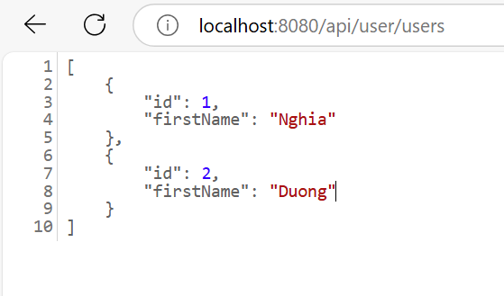
• Create API endpoint GET /api/user/{id} which get detail of a specific user.
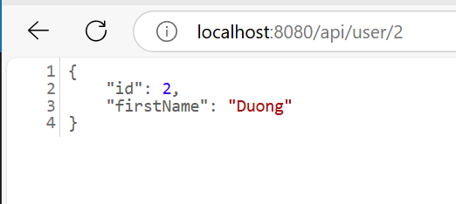
• Create API endpoint PUT /api/users{id} which update a specific user
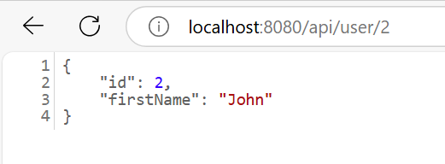
Create API endpoint DELETE /api/user/{id} which delete specific user
